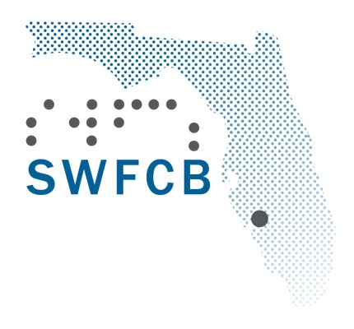**Southwest Florida Council of the Blind**

**P.O. Box 151922**

**Cape Coral, Fl. 33915**

**Phone 239-314-8768**

**Email swfcb1@gmail.com**

Dear Prospective Merit Award Recipient:

The Southwest Florida Council of the Blind is delighted to announce the opportunity to award four Merit Awards to a deserving Visually Impaired or Blind high school student in Lee County. The amount of the scholarship is $1,000.00.

To be considered, please ensure that all required documents, including the application, two (2) professional letters of reference, and proof of legal blindness, are submitted via email. Letters of reference can be provided by a teacher, employer, vision teacher, guidance counselor, or similar, while proof of legal blindness may be obtained from your attending ophthalmologist, optometrist, or state agency for the blind.

The Southwest Florida Council of the Blind is a proud chapter of the Florida Council of the Blind and an affiliate of the nationally recognized American Council of the Blind. We are an advocacy organization whose mission is to improve the lives of blind and visually impaired citizens of Lee County through education, information and community involvement.

We look forward to the opportunity to hear from you and ultimately, to award this scholarship to a deserving individual. Please visit our website to access the application at [www.swfcb.org](http://www.swfcb.org) click on the Advocacy and Education heading and you will find the application links at the bottom of the page. If you have any questions please reach out to Paul Lewis, Committee Chair at 941-841-9640 or lewpil1952@gmail.com.

Sincerely,

Chantale Napier

President

ELIGIBILITY CRITERIA

1. Applicant must be a resident of Lee County
2. Applicant must be legally blind with a bilateral eye condition, defined as having vision in the better eye of no more than 20/200 with corrective lenses or vision greater than 20/200 in the better eye, but with a restricted field of vision of no more than 20 degrees.
3. Applicant must have or be receiving a high school diploma or high school equivalency by the end of the current academic year
4. Applicant must show proof of acceptance to an institution of higher learning (university or trade school)
5. Applicant must demonstrate an ability to complete the chosen course of study
6. Applicant may be required to participate in an in-person interview at a location to be determined
7. All documents including the application, references and proof of legal blindness, must be submitted via email by April 10th, 2025.